ECE 447
Lab 3 – Timers
QUY PHAM
G00459909

- Introduction:
In this lab 3, we will build a program with MSP430 microcontroller. In this program, we will set the timer to count down. The maximum value which the timer can increase to is 999 and the minimum value is 0. When the timer is 0, the program needs to control the buzzer to sound on 500Hz with 40% PWM in 5 seconds. During buzzing, if the enabled or increased button is pressed, buzzer is off. When the increased button is pressed, if the timer is between 0 and 60, the timer is added to 10; if the timer is between 60 and 240, the timer is added to 20; if the timer is above 240, the timer is added to 30. For displaying, if the timer is less than 10, the third 7-segment is off. If the timer is less than 100, the program needs to show the tenth of the number on a 7-segment with decimal point. If the timer is above 100, the tenth of a number and decimal point is ignored.
- Microcontroller Concepts:
The microcontroller on-chip peripherals which we use:
- 7 pins of port P2 (H4) to display number on 3 7-segment displays.
- 3 pins of port P6 (H8) to make a multiplexer on 3 7-segment displays.
- 3 74HC373 buffers.
- 21 resistors for 3 7-segment displays.
- The on board power to power the two 7-segment display and the two buffers.
- Hardware Design:

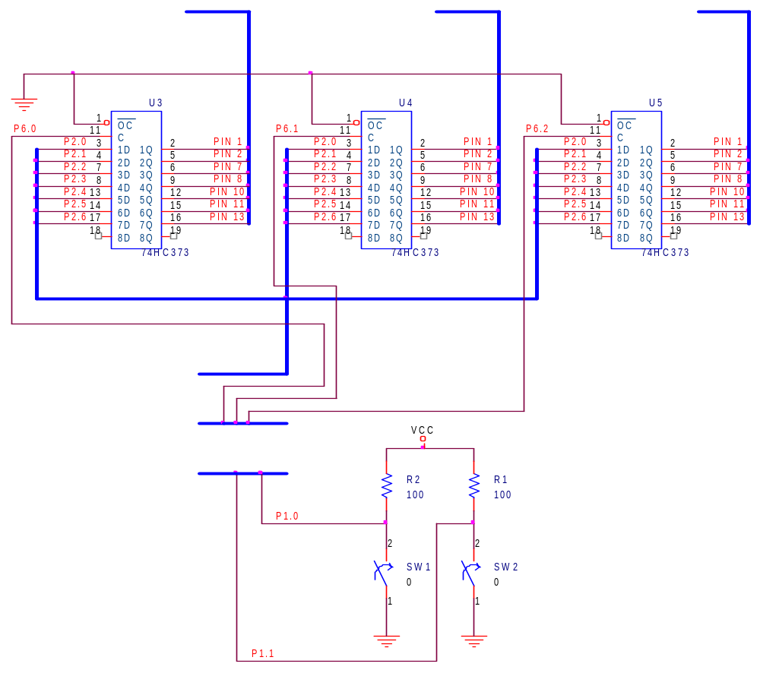
MSP430
PORT 1
PORT 6
PORT 2
First 7-Seg
Second 7-Seg
Third 7-Seg

- Software Design:
Initialize counter with zero
Start
Interrupt occurs ?
Yes
No
Enable btn pressed
Disable
SW1 or SW2 ?
Stop Counter.
Stop Buzzer.
SW1

Enable
SW2
Counter--;
Buzz 5 Sec if counter=0
Stop Buzzer if currently buzzing.
Increase Counter by 10, 20 or 30 depends on current count number

Output to PORT2 for displaying on the 3 7-segment displays. Use P6.0~2 for switching between 3 7-Segments

- Conclusion:
The lab result was what we expected. The counter worked and the numbers were shown correctly on three 7-segment displays. I encountered some problems when working with the code. One is how to use variables between c code files and assembly code files. Second is the 5 seconds delay for buzzing.
Here is what I did to fix the mentioned problems. To use a C variable in an assembly source code file, I put the keyword “EXTERN” before that variable name on top of the code in assembly file. With the 5 seconds delay, I made use of the timer for the counter to count for 5 seconds delay.

- Questions:
- Explain in detail how to implement PWM:
I used timer A for counting and displaying the numbers on the three 7-Segment Displays. The delay is 1/10 of a second. Here is the steps I used:
- Setup the timer A with: TACTL = TASSEL_1 | ID_0 | MC_1 | TACLR.
  - TASSEL_1: use ACLK as source.
  - ID_0: divided by 1 means use 32KHz
  - MC_1: up mode
  - TACLR: clear TAR before starting the timer.
- Setup the timer A to interrupt every 1/10 of a second:
  - Because 32KHz = 1 second in ACLK, and PWM requirement is 500Hz, so 1/10 second = 32KHz/500Hz = 64 cycles. Set TACCR0 = 64 will make an interrupt occurs every 1/10 of a second.
- We also need to setup timer B for a buzzer with:
  - TBCTL = TBSSEL_1|CNTL_3|ID_0|MC_1|TBCLR. It is the same as timer A except CNTL_3, this is for set up the counter to 8-bit counter.
  - We also set TBCCR0 to 64 cycles (1/10 of a second)
  - Set 40% duty cycle PWM: TBCCR4 = 26 (40% of 64 = 26 cycles).
  - To make the buzz sound:
    - I set port P3.5 to output and use P3SEL to switch the timer output to pin P3.5.
    - Set TBCCTL4 = OUTMOD_3 (set/reset) because the buzzer is active low. When TBR = TBCCR4, it set P3.5 to high. When TBR = TBCCR0, it set P3.5 to low.

40% PWM
500Hz (1/10 of second)

- Questions:
  - Compare and contrast the timer accuracy and sources of error for your timer implementations in Lab1 and Lab3.
The timer used in lab 3 is more accurate than lab 1 because in lab 3, we use clock to measure the time delay, which is more reliable than using the number to count as a timer delay in lab 1. The addition or subtraction operation in each machine might be different, that causes the timer delay to be vary in each one.
  - Is the accuracy of your Lab3 acceptable for this application? Explain.
So far, the accuracy of lab 3 is acceptable because the timer accuracy resolution for ACLK is 1/32KHz = 31 us. The timer in this lab 3 is count every 1/10 of a second = 0.1s which is larger than 31us. So the timer in this lab 3 is accurate and reliable.

- Source code:
- Main.c
#include "c_const.h"

void main(void)
{
WDTCTL = WDTPW + WDTHOLD; // stop watch dog timer to avoid time out reset
//-------------------------------------------------
// setup interrupt on button SW1 and SW2
//-------------------------------------------------
// set interrupt on btn SW1 and SW2 and define interrupt routine
P1DIR = 0; // set all pins to input
P1IE |= BIT0|BIT1; // interrupt on bit 0 and 1 (btn SW1 and SW2)
P1IES |= BIT0|BIT1; // falling edge
//-------------------------------------------------
// setup timer interrupt
//-------------------------------------------------
// initialize the PWM frequency (1 KHz)
// ACLK is 32kHz/1s:
// so to make the timer count every tenth of seconds, we set the timer to 1/10
// 32kHz / 10 = 3200 Hz
TACCR0 = 3200;
// turn on the timer
// - source: ACLK
// - input divider: /1
// - up mode
// - clear TAR
TACTL = TASSEL_1 | ID_0 | MC_1 | TACLR;
// enable timer interrupt for CCR0
TACCTL0 = CCIE;
P2DIR = 0xFF; // all output, data to 3 7-segment displays
P6DIR = 0xFF; // all output, use to switch data to each 7-segment displays

asm(" EINT"); // enable interrupt
for(;;)
{
// low power mode 3 (LPM3), only ACLK remains active
// this is the standard LPM when the MSP430 must awaken itself at regular time intervals
// and therefore needs a slow clock.
// SCG1--SCG0--OSC_OFF--CPU_OFF
// 1 1 0 1 = 0x0D0
// CPU, MCLK, SMCLK, DCO are disabled
asm("BIS.W #0x0D0, SR");
}
}
- Timer_isr.c:
#include "c_const.h"

int nums[] = {NUM0,NUM1,NUM2,NUM3,NUM4,NUM5,NUM6,NUM7,NUM8,NUM9};
unsigned int Timer = 0; // counter
int TimerEnFlag = 0; // TRUE: start count, FALSE: stop count
int Timer5SecDelay = 0;
int Timer5SecDelayEn = 0;

void SetBuzzerOn(); // func definition in buzzer_pwm_isr.asm
void SetBuzzerOff();

void IncTimer()
{
if(Timer <= 600)
{
Timer += 100;
}
else if(Timer <= 2400)
{
Timer += 200;
}
else if(Timer <= 9990)
{
Timer += 300;
if(Timer > 9990)
{
Timer = 9990;
}
}
}

void DisplayToSeg(int seg, int digit)
{
P2OUT = ~digit;
P6OUT = seg;
P6OUT = 0;
}

#pragma vector = TIMERA0_VECTOR
__interrupt void DisplaySegs_ISR(void)
{
int tenth = Timer%10,
one = (Timer/10)%10,
ten = (Timer/100)%10,
hundred = (Timer/1000)%10;
if(Timer < 100) // dont display the tenth of second ss.0 = ss.tenth
{
DisplayToSeg(EN7SEG3, 0x0); // Turn Off 3rd Seg
DisplayToSeg(EN7SEG2, nums[one]);
DisplayToSeg(EN7SEG1, nums[tenth]|DOT);
}
else if(Timer < 1000) // display the tenth of second
{
DisplayToSeg(EN7SEG3, nums[ten]);
DisplayToSeg(EN7SEG2, nums[one]);
DisplayToSeg(EN7SEG1, nums[tenth]|DOT);
}
else
{
DisplayToSeg(EN7SEG3, nums[hundred]);
DisplayToSeg(EN7SEG2, nums[ten]);
DisplayToSeg(EN7SEG1, nums[one]);
}

if(TimerEnFlag)
{
if(Timer > 0)
{
Timer--;
}
else
{
if(Timer5SecDelayEn == 0)
{
SetBuzzerOff(); // make sure buzzer is off before turn it on
SetBuzzerOn(); // buzz for 5s when timer = 0
Timer5SecDelay = 50; // buzz in 5 sec
Timer5SecDelayEn = 1;
}
}

if(Timer5SecDelayEn == 1) // buzz in 5 sec
{
if(Timer5SecDelay > 0)
{
Timer5SecDelay--;
}
else // then stop buzz
{
SetBuzzerOff();
}

}
}
else
{
Timer5SecDelayEn = 0;
}
}
- Button_isr.asm:
#include "asm_const.h"

;PUBLIC SetBtnISR ; so other file could call this function
EXTERN TimerEnFlag ; external variable for determining timer is currently enable or disable
EXTERN Timer5SecDelayEn
EXTERN IncTimer ; func locate in timer_isr.c: inc timer by 10,20 or 30 depends on current timer
EXTERN SetBuzzerOff ; func locate in buzzer_pwm_isr.asm: set buzz sound off

RSEG CODE ; place program in 'CODE' segment

;------------------------------------------------
BTNPUSH_ISR:
BIT.B #BIT0,&P1IFG ; if btn SW1 is pressed ?
JNZ EN_BTN
BIT.B #BIT1,&P1IFG ; if btn SW2 is pressed ?
JNZ INC_COUNT_BTN
JMP RESET_IF ; no btn is pressed, clear interrupt flag general and then exit
EN_BTN:
INV.B &TimerEnFlag
CALLA #SetBuzzerOff ; when enable btn is pressed, turn buzz off
JMP RESET_IF
INC_COUNT_BTN:
CALLA #SetBuzzerOff ; when increase timer btn is pressed, turn buzz off
CALLA #IncTimer ; func locate in timer_isr.c: inc timer by 10,20 or 30 depends on current timer
MOV.W #0,&Timer5SecDelayEn
RESET_IF:
BIC.B #BIT0|BIT1,&P1IFG ; clear interrupt flag so it won't jump back to this interrupt routine
RETI
;------------------------------------------------
COMMON INTVEC
ORG PORT1_VECTOR
DW BTNPUSH_ISR
END
- Buzzer_pwm_isr.asm:
#include "asm_const.h"

PUBLIC SetBuzzerOn ; make it public so other file could call it
PUBLIC SetBuzzerOff
EXTERN Timer5SecDelay ; declare in main.c (easier to declare in C)
EXTERN Timer5SecDelayEn
RSEG CODE

// Timer on CCR4 out to buzzer(active low)
// |-------| |------ this waveform goes out to P3.5 pin
// ___| |______|
SetBuzzerOn:
MOV.W #64,&TBCCR0 ; 32KHZ/500Hz = 64 cycles
MOV.W #26,&TBCCR4 ; 40% of a cycle (64*40/100=25.6 ~ 26)
MOV.W #TBSSEL_1|CNTL_3|ID_0|MC_1|TBCLR,&TBCTL ; ACLK, 8-bit counter, div /1, upmode, clear TAR
MOV.W #OUTMOD_3,&TBCCTL4 ; set/reset
BIS.B #BIT5,&P3DIR ; set P3.5 = output
BIS.B #BIT5,&P3SEL ; set P3.5 to timer output
RETA

SetBuzzerOff:
BIC.B #BIT5,&P3SEL
RETA

END
- C_const.h:
//constant and defines
#define WDTCTL *(unsigned int *)0x0120
#define WDTPW 0x5A00 // password for WDT
#define WDTHOLD 0x0080

#define P1IN *(unsigned char *)0x0020
#define P1OUT *(unsigned char *)0x0021
#define P1DIR *(unsigned char *)0x0022
#define P1IFG *(unsigned char *)0x0023
#define P1IES *(unsigned char *)0x0024
#define P1IE *(unsigned char *)0x0025
#define P2IN *(unsigned char *)0x0028
#define P2OUT *(unsigned char *)0x0029 // port2
#define P2DIR *(unsigned char *)0x002A
#define P2IFG *(unsigned char *)0x002B
#define P2IES *(unsigned char *)0x002C
#define P2IE *(unsigned char *)0x002D
#define P3IN *(unsigned char *)0x0018 // port3 for buzz
#define P3OUT *(unsigned char *)0x0019
#define P3DIR *(unsigned char *)0x001A
#define P6OUT *(unsigned char *)0x0035 // port6
#define P6DIR *(unsigned char *)0x0036
#define P5OUT *(unsigned char *)0x0031 //
#define P5DIR *(unsigned char *)0x0032
// timer A ports
#define TACTL *(unsigned int *)0X0160
#define TACCR0 *(unsigned int *)0X0172
#define TACCTL0 *(unsigned int *)0x0162
#define TACCR1 *(unsigned int *)0X0174
#define TACCTL1 *(unsigned int *)0x0164

#define TIMERA0_VECTOR (22 * 2u)

// timer A
#define OUTMOD_7 (7*0x20u) // PWM output mode: 7 - PWM reset/set
#define TASSEL_1 (1*0x0100u) // Clock Source: ACLK
#define MC_1 (1*0x10u) // Timer A mode control: 1 - Up to CCR0
#define TACLR (0x0004)
#define ID_0 (0*0x40u) // Timer A input divider: 0 - /1
#define CCIE (0x0010) // timer enable interrupt

#define EN7SEG1 BIT0
#define EN7SEG2 BIT1
#define EN7SEG3 BIT2
#define DISABLE7SEG BIT3
#define DOT BIT7

#define BIT0 0x01
#define BIT1 0x02
#define BIT2 0x04
#define BIT3 0x08
#define BIT4 0x10
#define BIT5 0x20
#define BIT6 0x40
#define BIT7 0x80
// 7 segments
#define SEGA BIT0
#define SEGB BIT1
#define SEGC BIT2
#define SEGD BIT3
#define SEGE BIT4
#define SEGF BIT5
#define SEGG BIT6
// numbers from 0-9
#define NUM0 SEGA|SEGB|SEGC|SEGD|SEGE|SEGF
#define NUM1 SEGB|SEGC
#define NUM2 SEGA|SEGB|SEGD|SEGE|SEGG
#define NUM3 SEGA|SEGB|SEGC|SEGD|SEGG
#define NUM4 SEGB|SEGC|SEGF|SEGG
#define NUM5 SEGA|SEGC|SEGD|SEGF|SEGG
#define NUM6 SEGA|SEGC|SEGD|SEGE|SEGF|SEGG
#define NUM7 SEGA|SEGB|SEGC
#define NUM8 SEGA|SEGB|SEGC|SEGD|SEGE|SEGF|SEGG
#define NUM9 SEGA|SEGB|SEGC|SEGD|SEGF|SEGG

#define DELAY_FACTOR 60000
#define DELAY_FACTOR2 60000
#define COUNT_MIN 0
#define COUNT_MAX 99
- Asm_const.h:
//constant and defines
P1IN EQU 0x0020 // port1
P1OUT EQU 0x0021
P1DIR EQU 0x0022
P1IFG EQU 0x0023
P1IES EQU 0x0024
P1IE EQU 0x0025
P2IN EQU 0x0028 // port2
P2OUT EQU 0x0029
P2DIR EQU 0x002A
P2IFG EQU 0x002B
P2IES EQU 0x002C
P2IE EQU 0x002D
P3IN EQU 0x0018 // port2
P3OUT EQU 0x0019
P3DIR EQU 0x001A
P3SEL EQU 0x001B
P6OUT EQU 0x0035 // port6
P6DIR EQU 0x0036
P5OUT EQU 0x0031 //
P5DIR EQU 0x0032

TACTL EQU 0X0160
TACCR0 EQU 0X0172
TACCR1 EQU 0X0174
TACCTL1 EQU 0x0164

TBR EQU 0x0190
TBCTL EQU 0X0180
TBCCR0 EQU 0X0192
TBCCTL0 EQU 0x0182
TBCCR1 EQU 0X0194
TBCCTL1 EQU 0x0184
TBCCR4 EQU 0X019A
TBCCTL4 EQU 0x018A

PORT1_VECTOR EQU (20 * 2u)
RESET_VECTOR EQU (31 * 2u)
TIMERB0_VECTOR EQU (29 * 2U) // 0xFFFA Timer B CC0
CNTL_3 EQU (3 * 0x0800u) // counter length: 8 bit
OUTMOD_3 EQU (3 * 0x20u) // PWM output mode: 3 - PWM set/reset
TBSSEL_1 EQU (1 * 0x0100u) // clk source: ACLK
MC_1 EQU (1 * 0x10u) // Timer A mode control: 1 - up to CCR0
TBCLR EQU (0x0004)
ID_0 EQU (0 * 0x40u) // Timer A input divider: 0 - /1
CCIE EQU (0x0010) // Timer Enable Interrupt

BIT0 EQU 0x01
BIT1 EQU 0x02
BIT2 EQU 0x04
BIT3 EQU 0x08
BIT4 EQU 0x10
BIT5 EQU 0x20
BIT6 EQU 0x40
BIT7 EQU 0x80

// 7 segments
SEGA EQU BIT0
SEGB EQU BIT1
SEGC EQU BIT2
SEGD EQU BIT3
SEGE EQU BIT4
SEGF EQU BIT5
SEGG EQU BIT6
// numbers from 0-15
//-AA-
//F B
//-GG-
//E C
//-DD-
NUM0 EQU SEGA|SEGB|SEGC|SEGD|SEGE|SEGF//SEGA+SEGB+SEGC+SEGD+SEGE+SEGF
NUM1 EQU SEGB|SEGC//SEGB+SEGC
NUM2 EQU SEGA|SEGB|SEGD|SEGE|SEGG//SEGA+SEGB+SEGD+SEGE+SEGG
NUM3 EQU SEGA|SEGB|SEGC|SEGD|SEGG//SEGA+SEGB+SEGC+SEGD+SEGG
NUM4 EQU SEGB|SEGC|SEGF|SEGG//SEGB+SEGC+SEGF+SEGG
NUM5 EQU SEGA|SEGC|SEGD|SEGF|SEGG//SEGA+SEGC+SEGD+SEGF+SEGG
NUM6 EQU SEGA|SEGC|SEGD|SEGE|SEGF|SEGG//SEGA+SEGC+SEGD+SEGE+SEGF+SEGG
NUM7 EQU SEGA|SEGB|SEGC//SEGA+SEGB+SEGC
NUM8 EQU SEGA|SEGB|SEGC|SEGD|SEGE|SEGF|SEGG//SEGA+SEGB+SEGC+SEGD+SEGE+SEGF+SEGG
NUM9 EQU SEGA|SEGB|SEGC|SEGD|SEGF|SEGG//SEGA+SEGB+SEGC+SEGD+SEGF+SEGG
NUMA EQU SEGA|SEGB|SEGC|SEGE|SEGF|SEGG//SEGA+SEGB+SEGC+SEGE+SEGF+SEGG
NUMB EQU SEGC|SEGD|SEGE|SEGF|SEGG
NUMC EQU SEGA|SEGD|SEGE|SEGF
NUMD EQU SEGB|SEGC|SEGD|SEGE|SEGG
NUME EQU SEGA|SEGD|SEGE|SEGF|SEGG
NUMF EQU SEGA|SEGE|SEGF|SEGG

DELAY_FACTOR EQU 0xFFFF
DELAY_SEC EQU 1
COUNT_MIN EQU 0
COUNT_MAX EQU 0xFF
TRUE EQU 0xFF
FALSE EQU 0

